Egocentric Camera – Basic User guide
[INSERT CONTACT INFORMATION OF THE RESEARCH TEAM]

POWER ON / OFF

Press the Mode button for two seconds [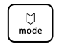 ] | 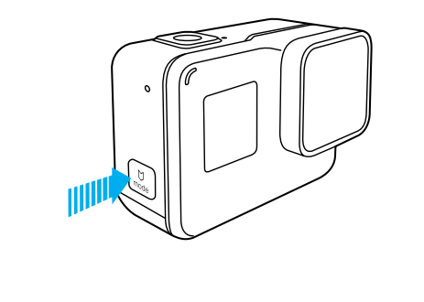
START / STOP RECORDING

Using the camera touch display:  Tap the icon in the lower left corner of the touch display | 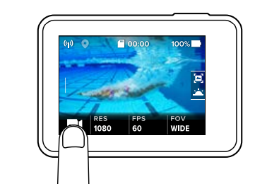
Using camera remote:  - Pair camera Remote to camera (For most cases, this should already be paired out of the box):  - From the main screen, swipe down from the top to bring up the menu and then select connect.  - From the connect menu select “Connect New Device”  - Now select the option “(Voice Remote)” A new message will appear on the camera screen asking you to power on the Remote. Set the camera aside.  - Power on the remote by pressing hold the small power button on the side of the remote for 8 seconds.  - From the main screen, swipe down from the top to bring up the menu and then select connect. | 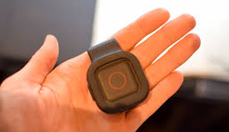
Using camera Apps:  Live preview, playback and full camera control (including start and stop recording) can be operated from the camera Apps. | 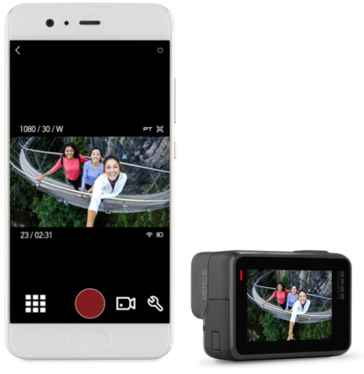
CHARGING THE BATTERY

- Hold down the Latch Release button on the side door (if available), then slide the door open.  - Connect the camera to a computer or other USB charging adapter using the included USB-C cable.  - Power off the camera. The camera status light turns on during charging and turns off when charging is complete. When charging with a computer, be sure that the computer is connected to a power source. If the camera status light does not turn on, use a different USB port. | 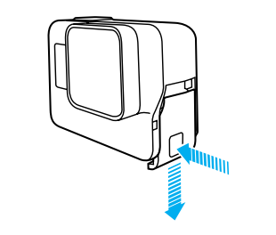
VIEWING VIDEOS

Using the camera touch display:  - Swipe right to open the gallery. If your microSD card contains a lot of content, it might take a minute for it to load.  - Scroll through the thumbnails. Note: For photo series (Burst, Time Lapse, Night Lapse and Continuous photos), the thumbnail displays the first photo in the series.  - Tap a video or photo to open it in full-screen view.  - To add a HiLight Tag, tap []. HiLight Tags make it easy to bookmarks videos for later retrieval.  - To return to the thumbnails screen, tap [].  - To exit the gallery, swipe down. | 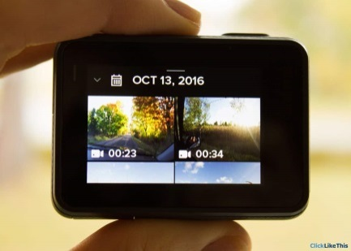
Using camera Apps:
Live preview, playback and full camera control can be operated from the camera Apps.

DELETE SELECTED VIDEO FILES

Using microSD card:  - connect the card reader to the computer  - Remove microSD card from the camera:  - Hold down the Latch Release button on the battery door, then slide the door open.  - To remove the card, press it into the slot with your fingernail and it will pop out.  - Insert the microSD card into the microSD slot/reader on your computer or the tablet provided (via File Manager App):  - The microSD card slot (accepts up to 128GB capacity cards) on the tablet, can be found under the rear cover.  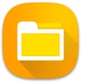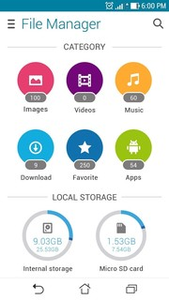  File Manager  - Delete selected video files on your card | 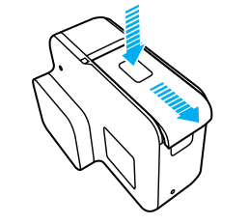  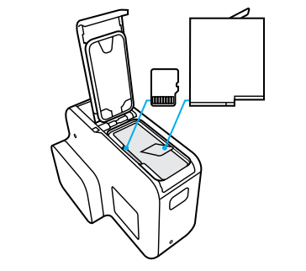  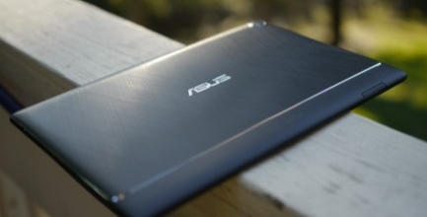  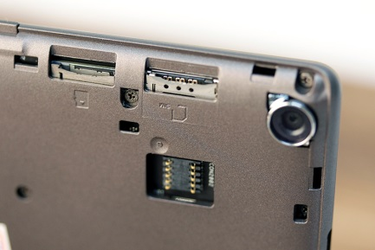
Using USB cable:  - Connect the camera to your computer using the included USB-C cable  - Power on the camera and follow the on-screen instructions  - Delete selected video files on your card | 